GLAB: Microsoft 365 OneDrive and Collaboration

# Introduction

OneDrive is a cloud-based service that enables you to store and protect files, share files with others, access files from anywhere using an app or web browser, and restore all files to a previous date and time. You can easily and securely store and access your files from all your devices. You can work with those within our organization, and with those outside of your organization, and you can terminate sharing whenever you want. OneDrive helps protect your work through advanced encryption while the data is in transit and at rest in data centers.

Before proceeding, ensure that you have an email address of one of your peers/colleagues. Refer to **Discussion: Share Microsoft Account** to retrieve an email address from one of your peers to complete this guided lab.

**Note:** Microsoft 365 is constantly evolving. The exact steps and screenshots may differ from this lab.

# Objectives

* Explore OneDrive and create folders and a file in the cloud.
* Share a file and collaborate.
* Organize your emails.

# Prerequisites and Recommended Equipment

* A Windows computer with Internet access.
* The completion of the following labs:
  + GLAB 5.1.1: Sign Up for a Microsoft Account
  + GLAB 5.2.1: Add Contacts into Outlook
  + GLAB 5.2.2: Outlook.com Email
  + GLAB 5.3.1:: Outlook.com Calendar

# Part 1: Explore OneDrive, and create folders and a file in the cloud

In part 1, you will explore OneDrive via your web browser. You will create several folders and one Word document.

## Step 1: Launch OneDrive and open a file.

* + 1. *Using a* ***web browser****, navigate to* [*https://www.office.com/*](https://www.office.com/) *and sign in using* ***your @outlook.com*** *account.*
    2. *On the* ***All apps | Microsoft Office*** *page, click on the* ***OneDrive*** *button or click on the* ***OneDrive*** *icon on the left vertical toolbar.  
       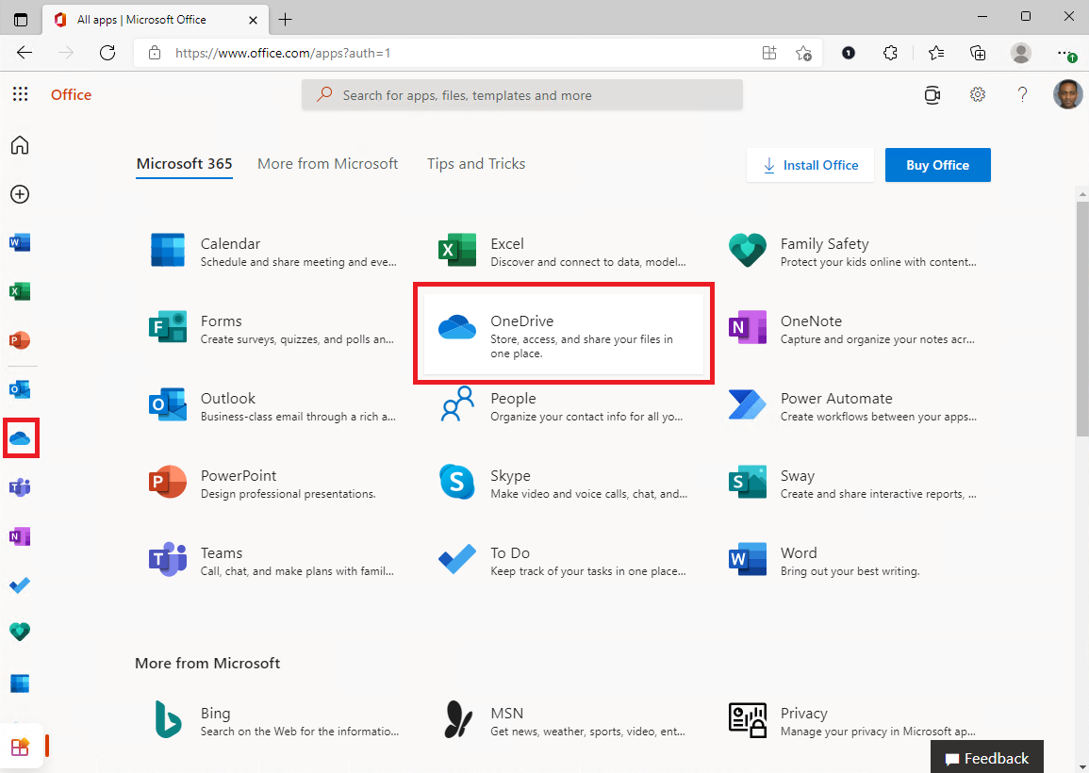*
    3. *Click on the* ***Getting started with OneDrive.pdf*** *to open the file in your browser.   
       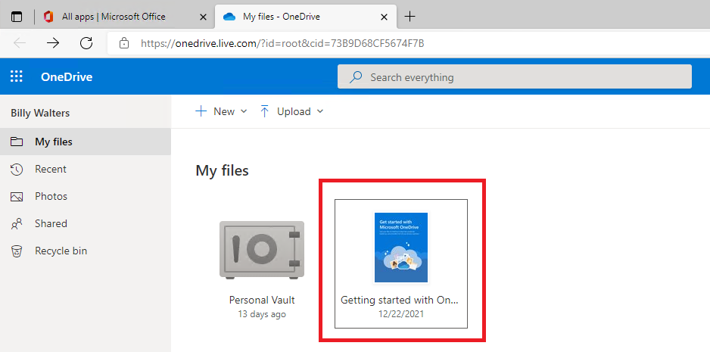*
    4. *Review the content of the file and answer the questions. Record your responses in a safe area to be utilized in a discussion.*Question:
       - 1. *What are some of the benefits OneDrive has to offer?*
    5. *Select or open a file, which will trigger the* ***file-specific*** *toolbar.   
       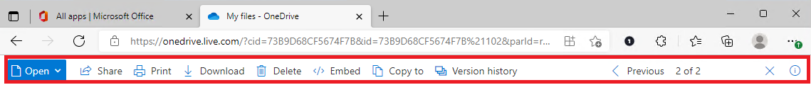*Question:
       - 1. *What are some of the actions you can perform on the file?*

*f.* ***Close*** *the file by clicking on the* ***X*** *button on the right-hand side of the file-specific toolbar.  
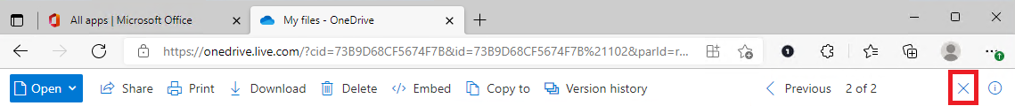*Question:

(2) *The file* ***Getting Started with OneDrive.pdf*** *resides in the* ***OneDrive My files*** *folder. Where is this folder located?*

## Step 2: Create folders

* + 1. *Back on* ***OneDrive****, click on the* ***+ New*** *button and select* ***Folder*** *from the dropdown menu.   
       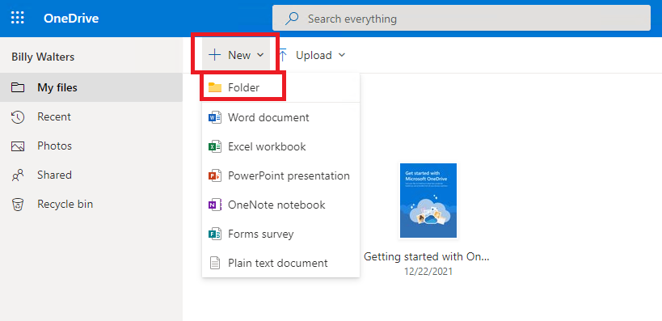*
    2. *On the* ***Create a folder*** *dialog box, type* ***Employment Essentials*** *into the* ***Enter your folder name*** *text field and click on the* ***Create*** *button.  
       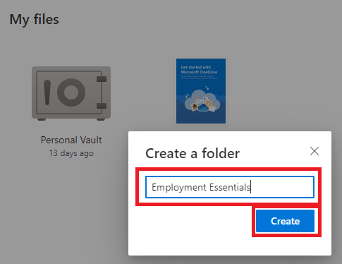*
    3. *OneDrive now displays the new* ***Employment Essentials*** *folder under* ***My Files****. Click on the* ***Employment Essentials*** *icon to navigate into it.   
       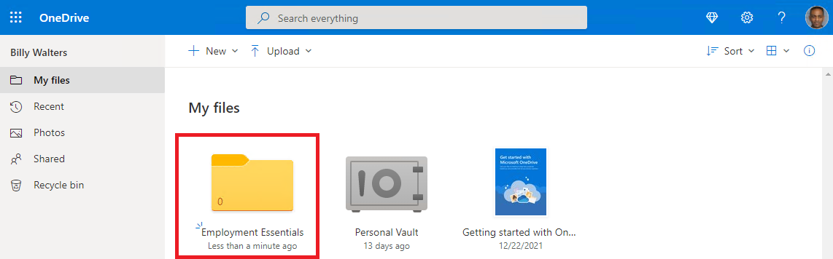*
    4. *Create* ***three*** *more folders inside the* ***Employment Essentials*** *folder. Name the folders:*

|  |  |  |
| --- | --- | --- |
| ***Resumes*** | ***Cover Letters*** | ***Elevator Pitch*** |

## 

## Step 3: Create an elevator pitch.

* + - *Navigate to* [*Writebuddy AI Elevator Pitch Generator*](https://writerbuddy.ai/writing-tools/elevator-pitch-generator)
    - 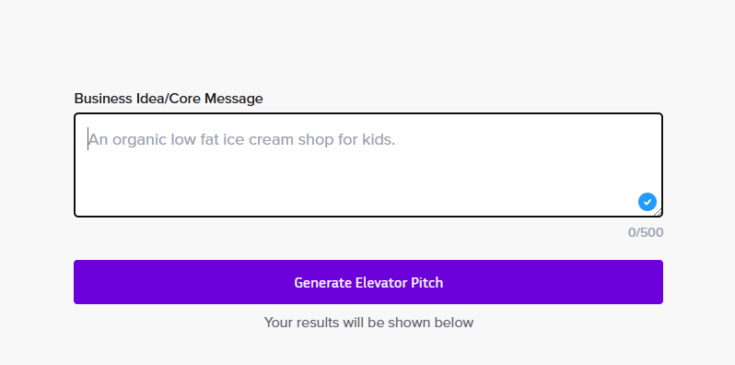
    - *Enter a few sentences about yourself and press “Generate Elevator Pitch”*
    - *It will give you a couple of pitches to choose from, pick one and paste it into a google document.*
    - *Navigate to the* ***OneDrive browser tab → My files → Employment Essentials → Elevator Pitch*** *folder and click on the* ***+ New*** *button.  
      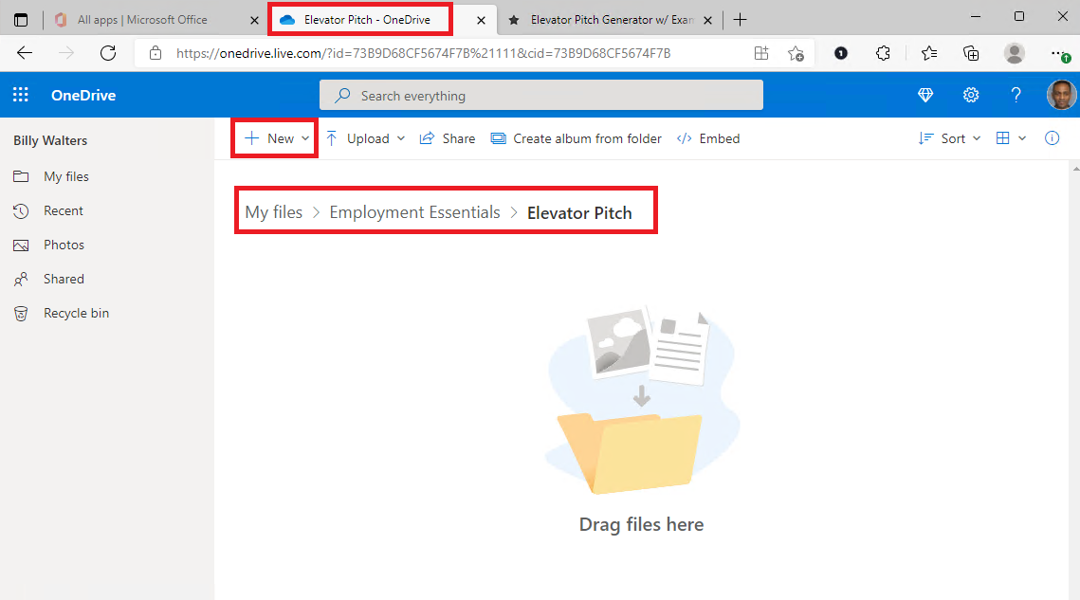*
    - *Select* ***Word document*** *from the dropdown menu.  
      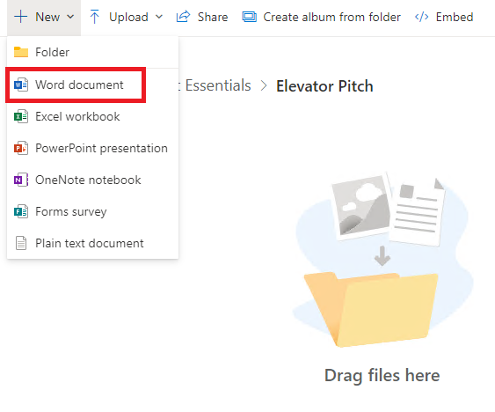*
    - *On* ***Word →******Document1****, right-click and select* ***Paste*** *from the pop-up menu.  
      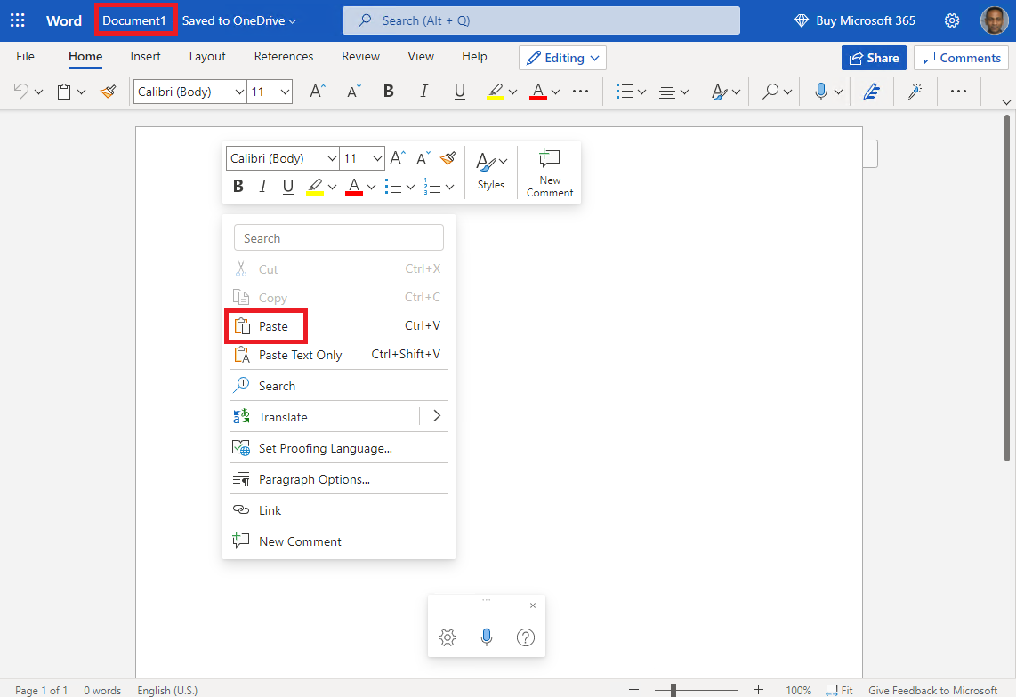*
    - *To* ***rename*** *the file, click on* ***Document1 - Saved to OneDrive****. Type* ***MyPitch01*** *into the* ***File Name*** *textbox, replacing Document1.   
      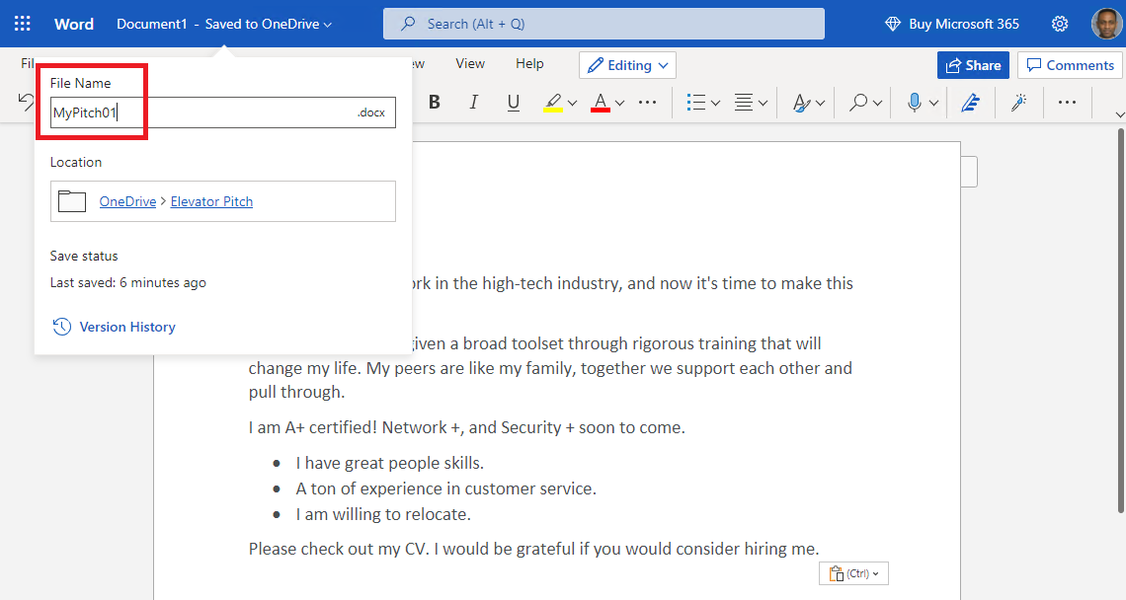*
    - *To complete the action, click* ***anywhere*** *on the document. Word will display the new file name.   
      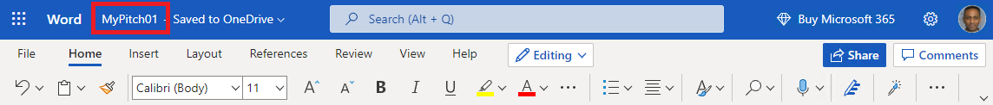*
    - *Back on* ***Onedrive****, navigate to the* ***My Files → Employment Essentials → Elevator*** *folder.*

**Part 2: Share a file and collaborate.**

In part 2, you will share your elevator pitch with a peer. Note that there are several ways to accomplish this in OneDrive. The route presented here is, in our opinion, best for ensuring you share the file only with whom you intend to share it with.

Once the file is shared, your peer may elect to provide feedback. If a peer shares their pitch with you, you are encouraged to review the pitch and provide feedback using the notes feature.

## Step 1: Share your elevator pitch.

* + 1. *On the* ***OneDrive*** *browser window, navigate to the* ***My files → Employment Essentials Elevator Pitch*** *folder, right-click on the* ***MyPitch01.docx*** *file, and select* ***Details*** *from the pop-up menu.  
       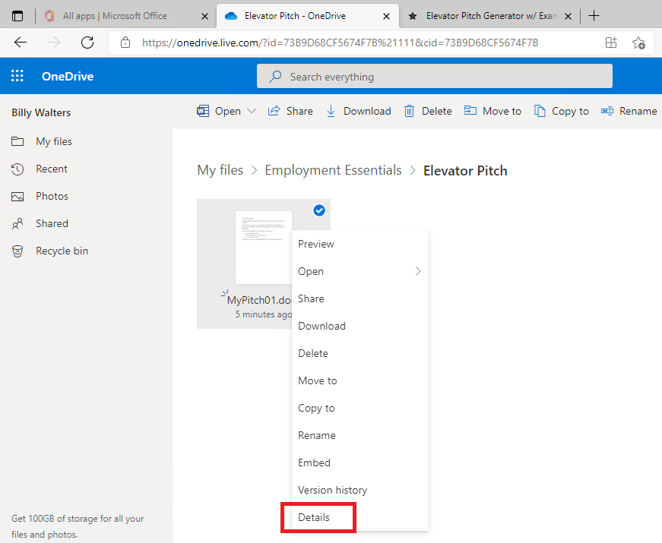*
    2. *Click on the* ***Manage access*** *link in the* ***Has access*** *section on the Details pane.   
       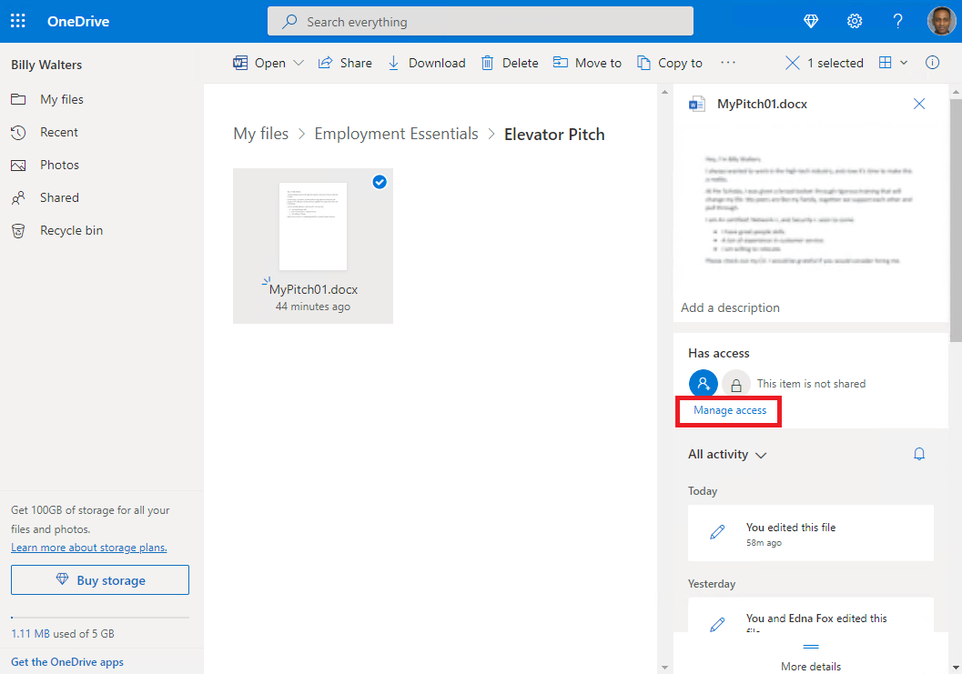*
    3. *On the* ***Manage Access*** *pane, click on the* ***Add People*** *link.*  
       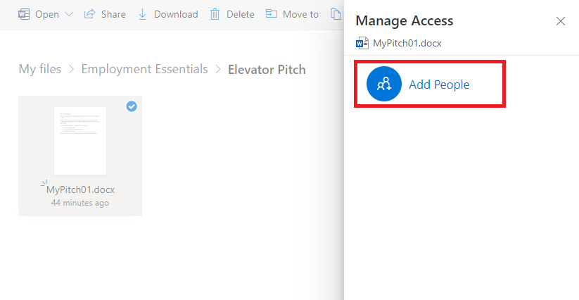
    4. *On the* ***Share ‘MyPitch01.docx’*** *dialog box, note the available options and click on the* ***Email*** *link.  
       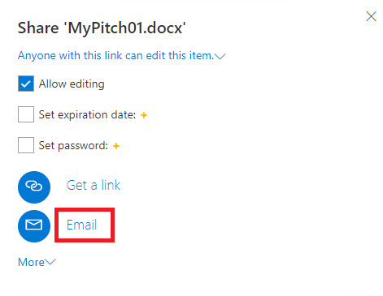*
    5. *Next, start typing the name or email of the peer you wish to share the document with into the* ***Enter a name or email address*** *text box. OneDrive should find the email address in your contacts list and automatically help you complete it. After entering the name or email address, click on the* ***Share*** *button.***Note:** You can add a custom message that will appear on the email inviting the contact to collaborate on the file.   
       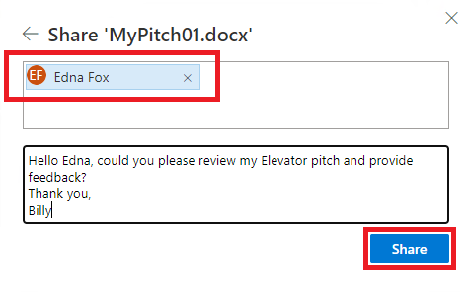

## Step 2: Collaborating.

In step 2, you will accept an invitation to collaborate and provide feedback on the elevator pitch shared with you. If no one shares their pitch with you, carefully review the steps below to gain a better understanding of how you can collaborate. You will review the pitch and use the **note tool** to communicate what you think could be improved.

* + 1. *There should be an email in your* ***Outlook Inbox*** *notifying you that your peer has shared a file with you. Use your browser to access* ***Outlook mail****. Click on the* ***incoming message*** *and click on the* ***Open*** *button in the expanded email view.  
       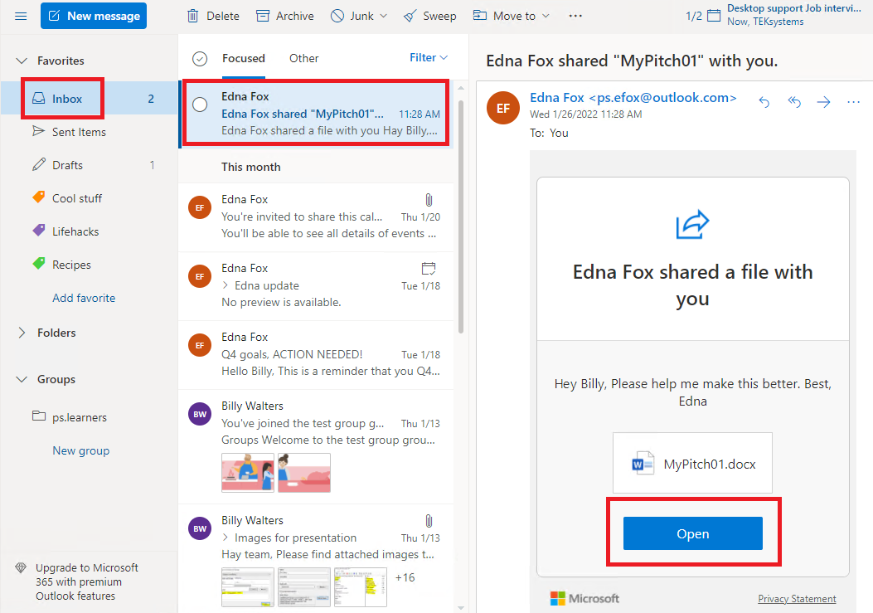*
    2. *The shared* ***elevator pitch*** *is now open in* ***Word****. To edit the document, click on the* ***Edit Document*** *dropdown menu and select* ***Edit Make quick changes right here using Word****.  
       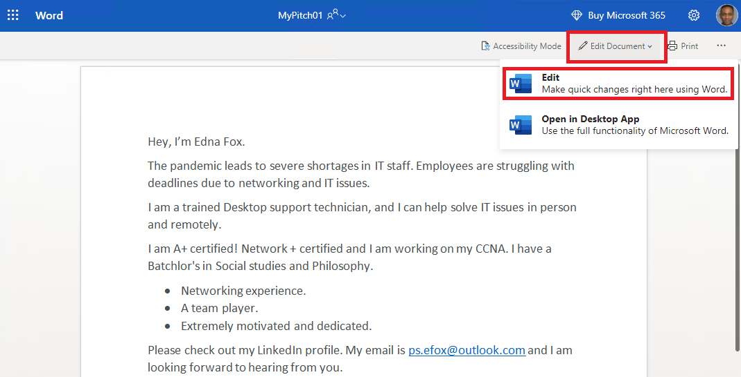*
    3. *Microsoft 365 may ask you to* ***confirm*** *the account you want to use to access the document. If so, ensure that you are using your* ***ps.[account]@outlook.com*** *and click on the* ***Continue*** *button.  
       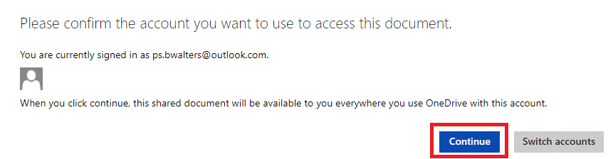*
    4. *Word will now display the* ***editing toolbar*** *and allow you to make changes to the document. Review the document.* ***Highlight*** *a word or sentence that you think needs work, right-click on the* ***highlighted section,*** *and select* ***New Comment*** *from the pop-up menu.  
       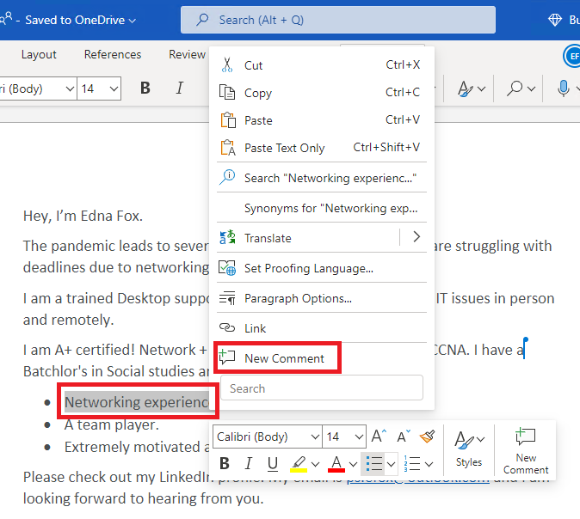*
    5. *An editable* ***new comment*** *will appear to the right of the document. Type your* ***comment*** *into the text box. To ensure the owner of the document gets an email notification, use the* ***@ sign*** *with their email address. Click on the* ***paper airplane*** *button to finish creating the comment.*

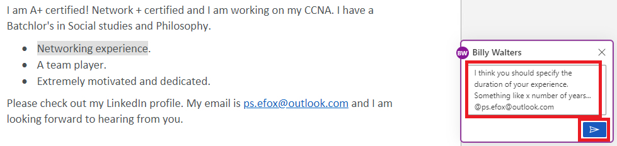

## 

* + 1. *There should be an email from in your* ***Outlook Inbox*** *notifying you that a peer has left a comment in your* ***MyPitch01.docx****. Click on the* ***incoming message*** *and click on the* ***Go to comment*** *button in the expanded email view.  
       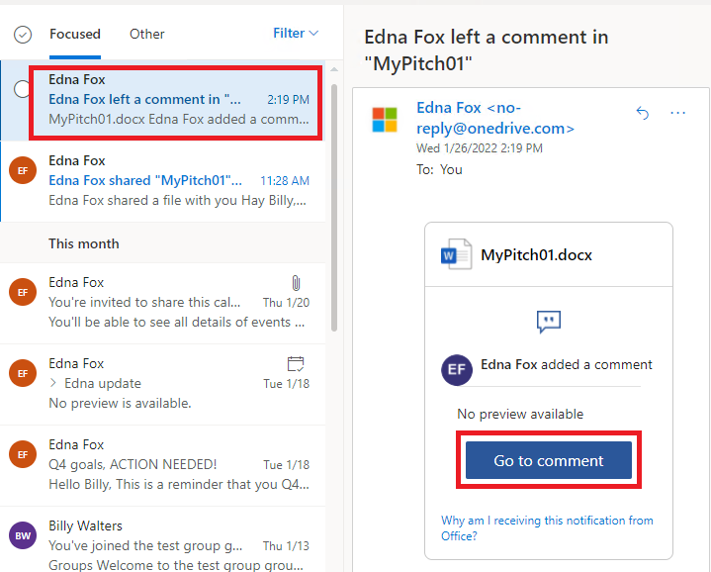*
    2. *You can now see the comments on your* ***MyPitch01.docx*** *document open in* ***Word****.* ***Review*** *the* ***comment*** *and take* ***action****.* ***Notify*** *your partner that you have* ***acted upon their feedback*** *by* ***replying*** *to the comment and using the* ***@ sign*** *with the sender’s email* ***in the reply****. When you are finished, click on the* ***paper airplane*** *button.  
       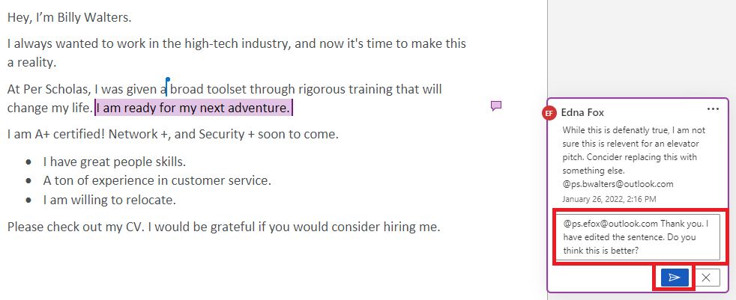*
    3. *Once the sender notifies you that they* ***approve*** *your action, click on the* ***three horizontal dots*** *on the* ***top right of the first comment*** *and select* ***Resolve thread*** *from the pop-up menu.   
       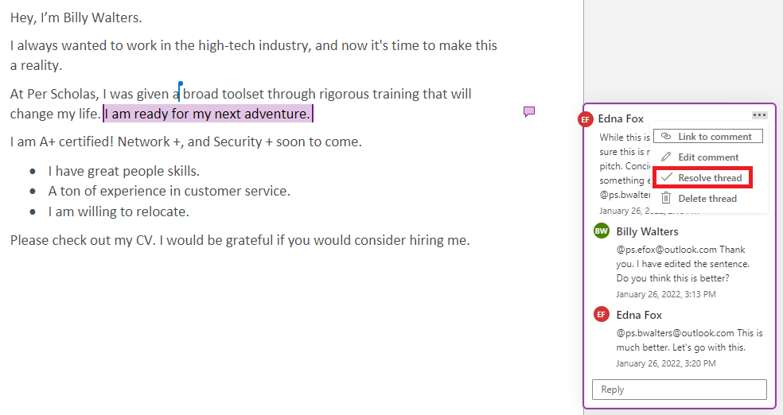*
    4. *The comment, being resolved, will* ***disappear*** *from the document. To* ***view*** *the resolved comment thread, click on the* ***Comments*** *button on the top toolbar.  
       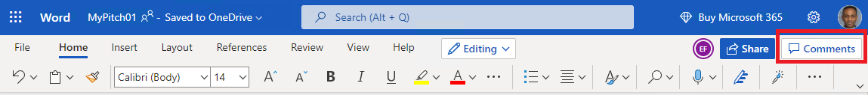*

# 

# Part 3: Syncing local folders.

You can use OneDrive to back up locally stored documents to the Cloud. By syncing folders to OneDrive, a copy of the folder’s content is stored securely in the Cloud. In part 3, you will use the built-in Windows OneDrive application to sync the **Microsoft 365 Labs** folder you created with OneDrive cloud service.

**NOTE:** If you have a personal Microsoft account and are already utilizing this feature, we **strongly recommend** performing this part of the lab using a **Windows virtual machine**.

## Step 1: Sign in to the Windows OneDrive application.

By default, OneDrive syncs your desktop, documents, and pictures folders. In this step, you will sign in to the Windows OneDrive application and opt out of the default synchronization settings.

* + 1. *Launch* ***Windows File Explorer****. Locate and click on the* ***OneDrive*** *item on the left navigation pane.   
       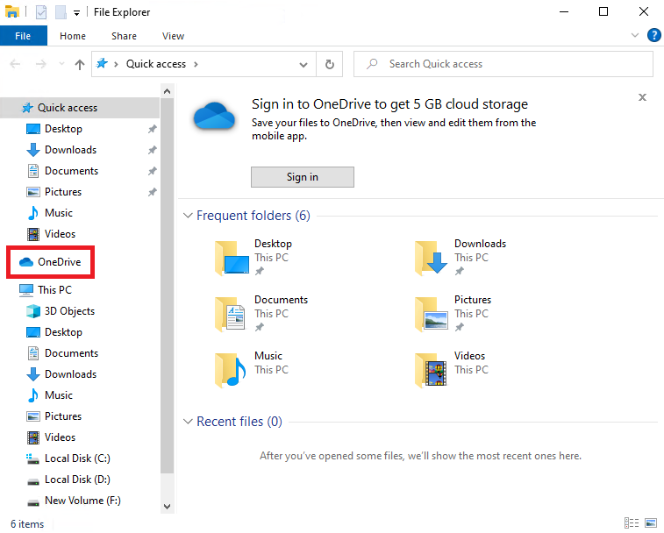*
    2. *On the* ***Set up OneDrive*** *window, enter your* ***@outlook.com*** *email into the* ***Email address*** *text field and click on the* ***Sign in*** *button.  
       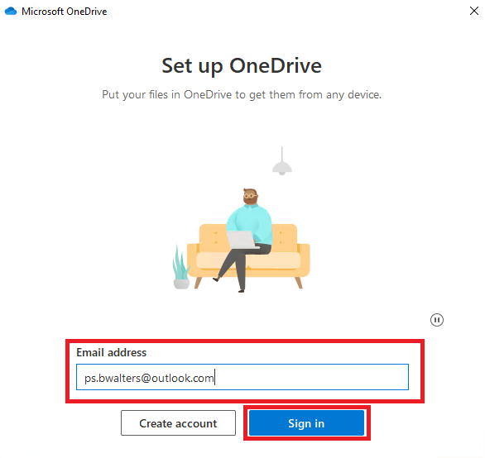*
    3. *Next, type your* ***password*** *into the* ***Enter password*** *text field and click on the* ***Sign in*** *button.  
       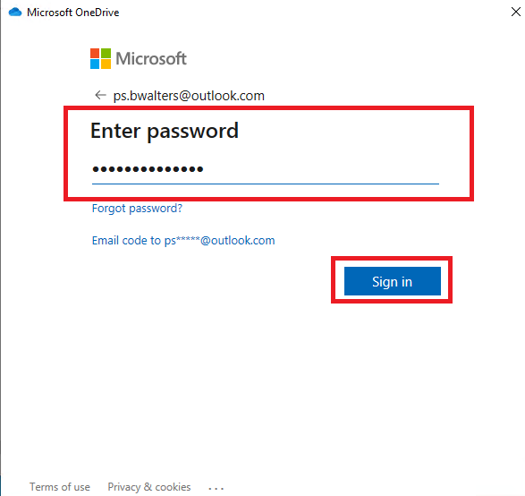*
    4. *If the* ***Microsoft respects your privacy*** *window appears, review its contents and click on the* ***Next*** *button.  
       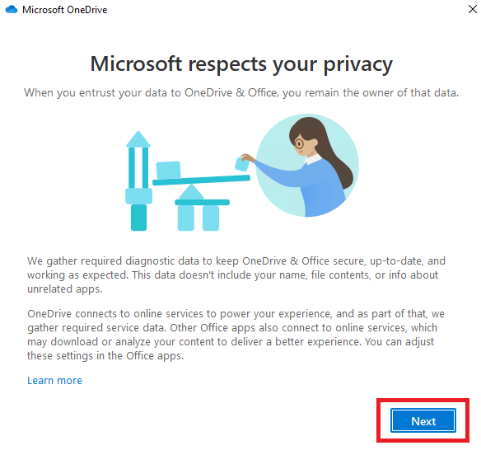*
    5. *If the* ***Getting better together*** *window appears, review its contents and select whether or not you want to* ***send optional data about OneDrive & Office to Microsoft****, and click on the* ***Next*** *button.  
       *
    6. *On the* ***Your OneDrive folder*** *window, note the local path to your OneDrive folder. You can change this path if you wish. Click on the* ***Next*** *button.  
       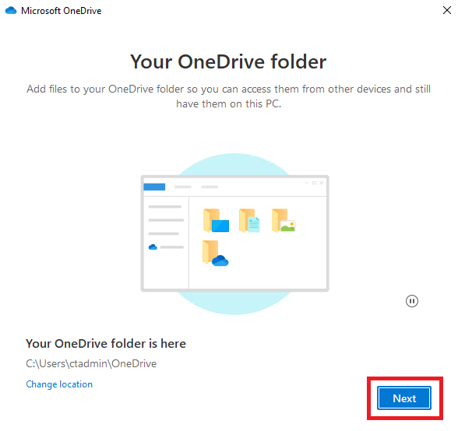*
    7. *On the* ***Back up your folders window****, uncheck the checkmarks on the* ***Desktop****,* ***Documents****, and* ***Pictures*** *folders.*
    8. *Select* ***Continue.*** 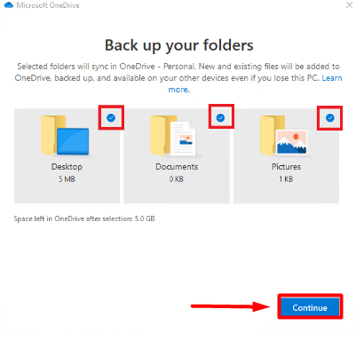
    9. ***Review*** *the notification, and click on the* ***Skip*** *button.  
       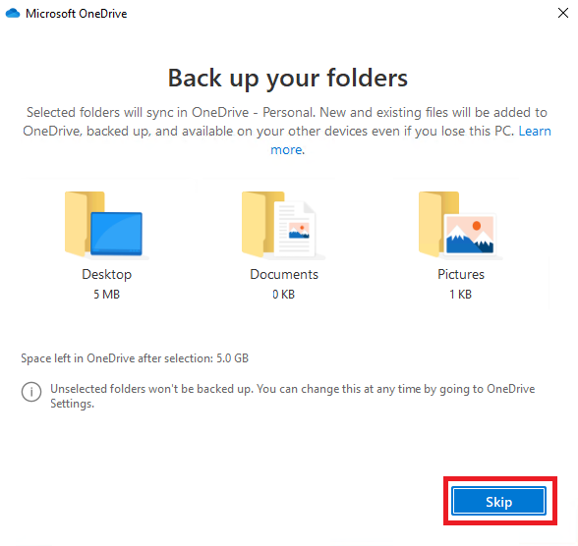*
    10. *On the* ***Get the most out of your OneDrive*** *window, click on the* ***Not now*** *button.  
        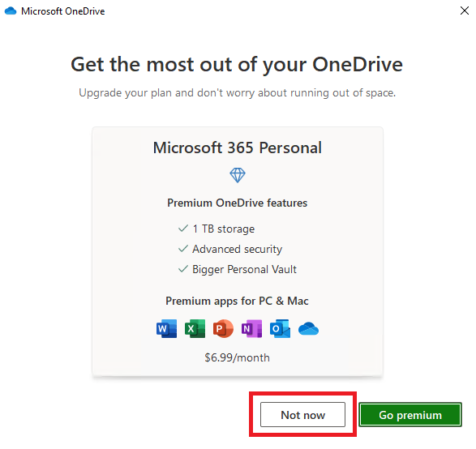*
    11. *Review the information on the* ***Get to know your OneDrive*** *window, and click on the* ***Next*** *button.  
        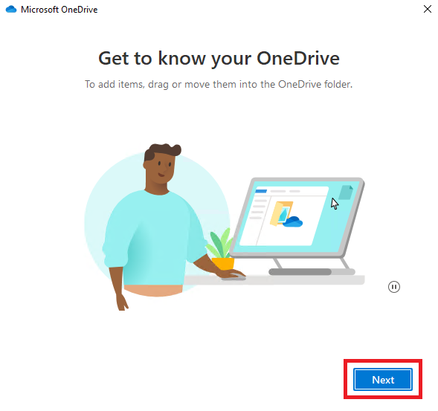*
    12. *Review the information on the* ***Share files and folders*** *window, and click on the* ***Next*** *button.  
        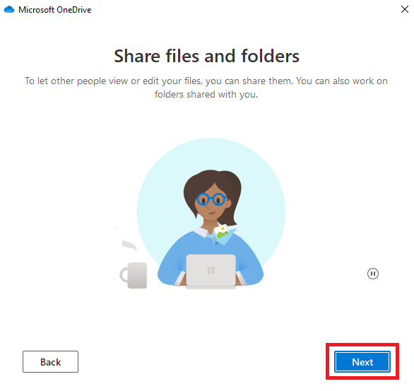*
    13. *Review the information on the* ***All your files, ready and on-demand*** *window, and click on the* ***Next*** *button.  
        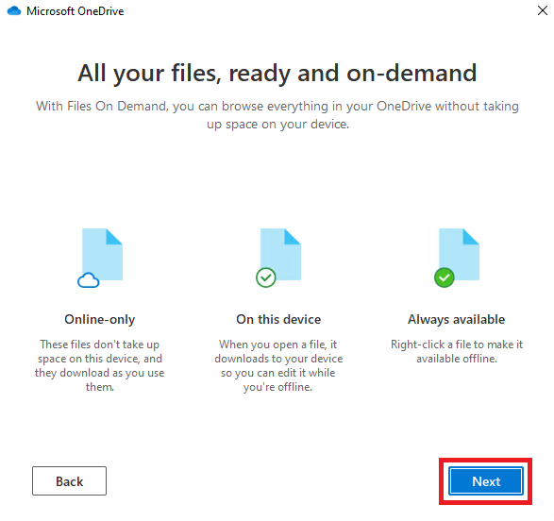*
    14. *On the* ***Get the mobile app*** *window, click on the* ***Later*** *button.  
        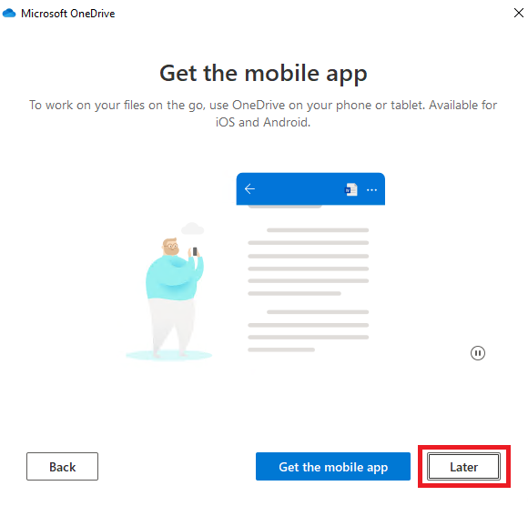*
    15. *Finally,* ***Microsoft OneDrive*** *announces that Your* ***OneDrive is ready for you****. Click on the* ***Open my OneDrive folder*** *button.  
        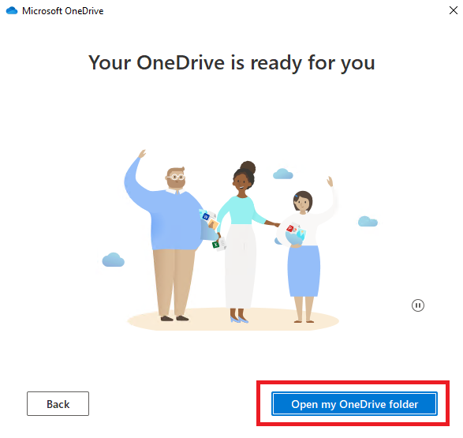*

## Step 2: Sync the Microsoft 365 Labs folder with OneDrive.

By opting out of the default synchronization, at this point, only the cloud-based OneDrive My files folder and the local OneDrive folder are synchronized. The Employment Essentials folder you created using your web browser is now present on your local storage device. Any changes to the local OneDrive will sync with the cloud OneDrive, and vice versa. In this step, you will sync your Microsoft 365 Labs folder with OneDrive.

* + 1. *On your Windows computer, use* ***File Explorer*** *to navigate to the location of your* ***Microsoft 365 Labs*** *folder. Right-click on the* ***Microsoft 365 Labs*** *folder and select* ***Cut*** *from the pop-up menu.***Note:** the location of this folder on your device may **differ** from the one displayed in the image below. 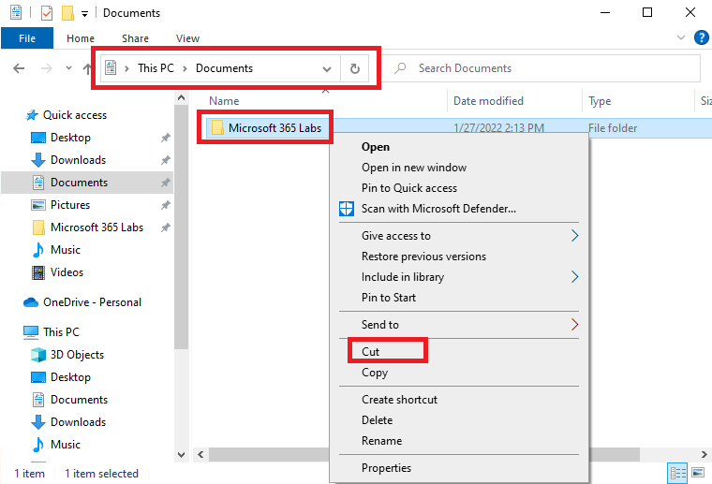
    2. *Using* ***File Explorer****, navigate to your* ***local OneDrive folder****. Right-click anywhere on the white space and select* ***Paste*** *from the pop-up menu.  
        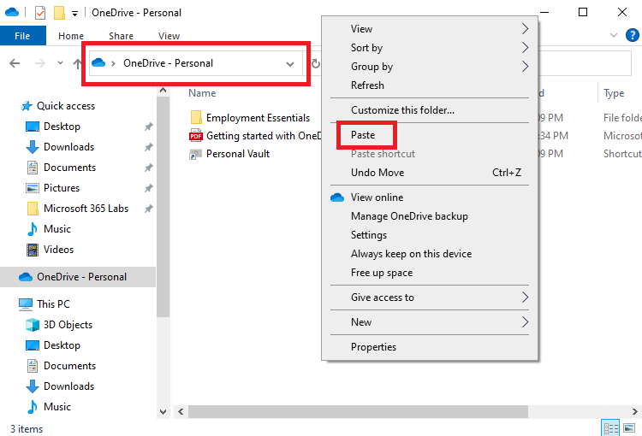*
    3. *Note the* ***synchronizing icon*** *under the* ***Status*** *column in file explorer.  
       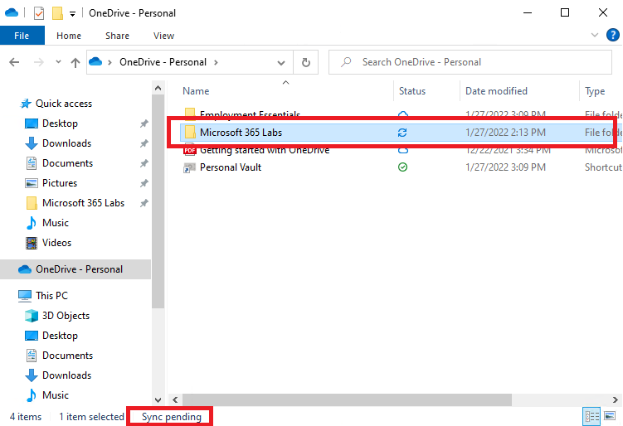*

## Step 3: Explore OneDrive settings.

Explore and enlighten yourself with options and settings related to the OneDrive application.

* + 1. *On your Windows computer, use* ***File Explorer*** *to navigate to your* ***OneDrive*** *folder. Right-click on the* ***OneDrive - Personal*** *item on the* ***navigation pane*** *and select* ***Settings*** *from the pop-up menu. Answer the following questions. Record your responses below.  
       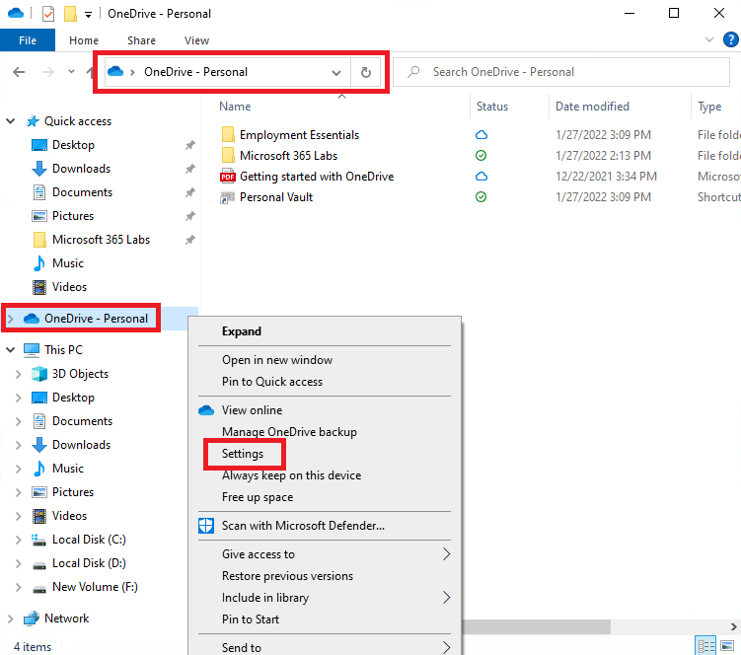*

*Questions:*

* + 1. *On the OneDrive Settings window, where can you configure backing up your desktop, documents, and pictures folders?*

|  |
| --- |
| *[Type answer here]* |

* + 1. *On the OneDrive Settings window, where can you sever the connection between your local and cloud OneDrive?*

|  |
| --- |
| *[Type answer here]* |

* + 1. *On the OneDrive Settings window, where can you set the Upload and Download rates?*

|  |
| --- |
| *[Type answer here]* |

* + 1. *On the OneDrive Settings window, where can you disable OneDrive notifications, suggesting new collections of photos and videos?*

|  |
| --- |
| *Its under options, you can adjust notifications and photos there. There is also an option to import photos and things from a different cloud.* |

## Part 4: Reflection

If you have not done so already, download a copy of the Guided Lab and save it in location on your laptop/desktop that can be easily accessed. You can also choose to save it to your Microsoft OneDrive. Once you have completed the Reflection questions and questions in Part 3 of this lab, follow the instructions for submission.

* + 1. Describe how Microsoft OneDrive supports productivity and collaboration.

|  |
| --- |
| *OneDrive makes it easy to access files and documents from anywhere. It also allows for you to create collaboration through sharing which is also user friendly.* |

* + 1. Why do you believe it is important to have strong email management skills? This can be applied to professional or personal scenarios.

|  |
| --- |
| *Because emailing is one of the main ways people and organizations communicate with one another. It is also a form of organization!* |

## Part 5: Submission

1. When you have completed the lab, including responding to the reflection questions, submit a copy of the lab on Canvas to have the task marked as complete.
2. Suggested labeling of the pdf would be ***first initial.last name. GLAB #***
   1. Example: j.smith.GLAB 5.3.2